**Scenario: Launch Automation_Practice_Url**

**Step: Launch "Automation_Practice_Url" WebPage - PASS**

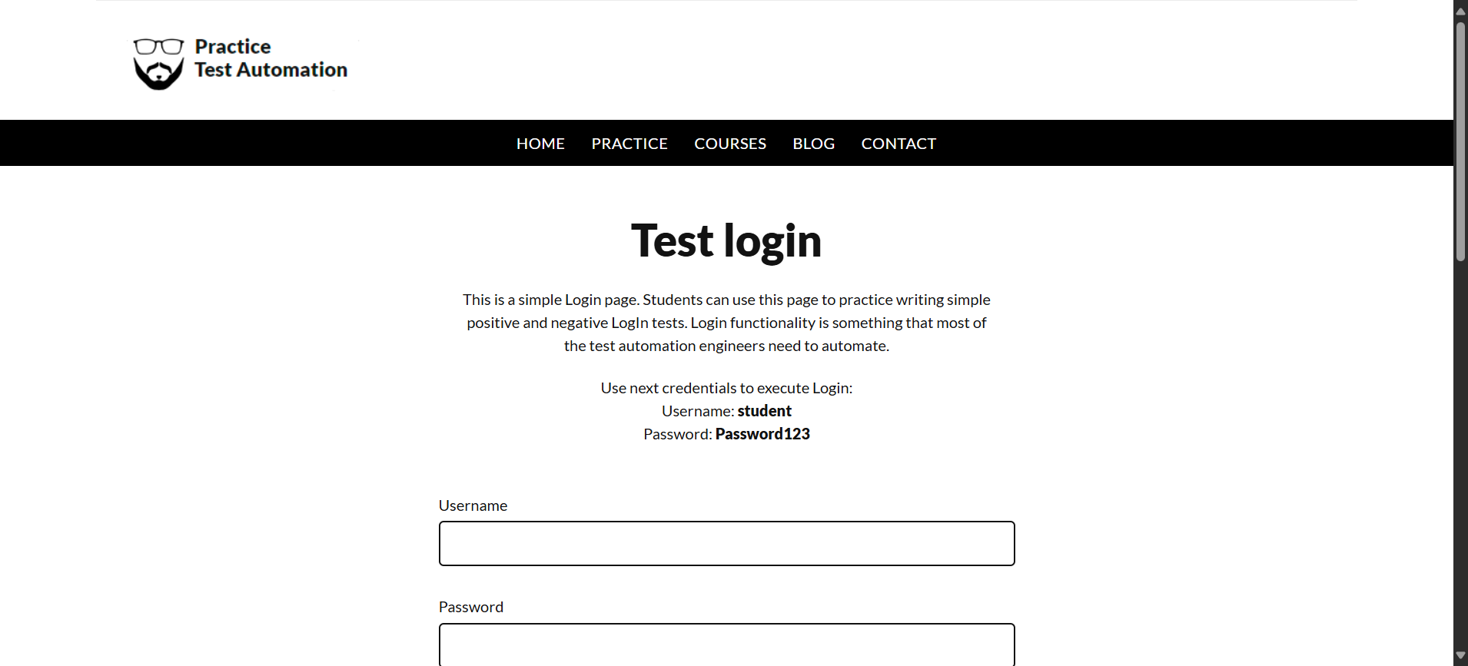

**Step: Enter UserName "username" into "Username" textbox at "LoginPage" page - PASS**

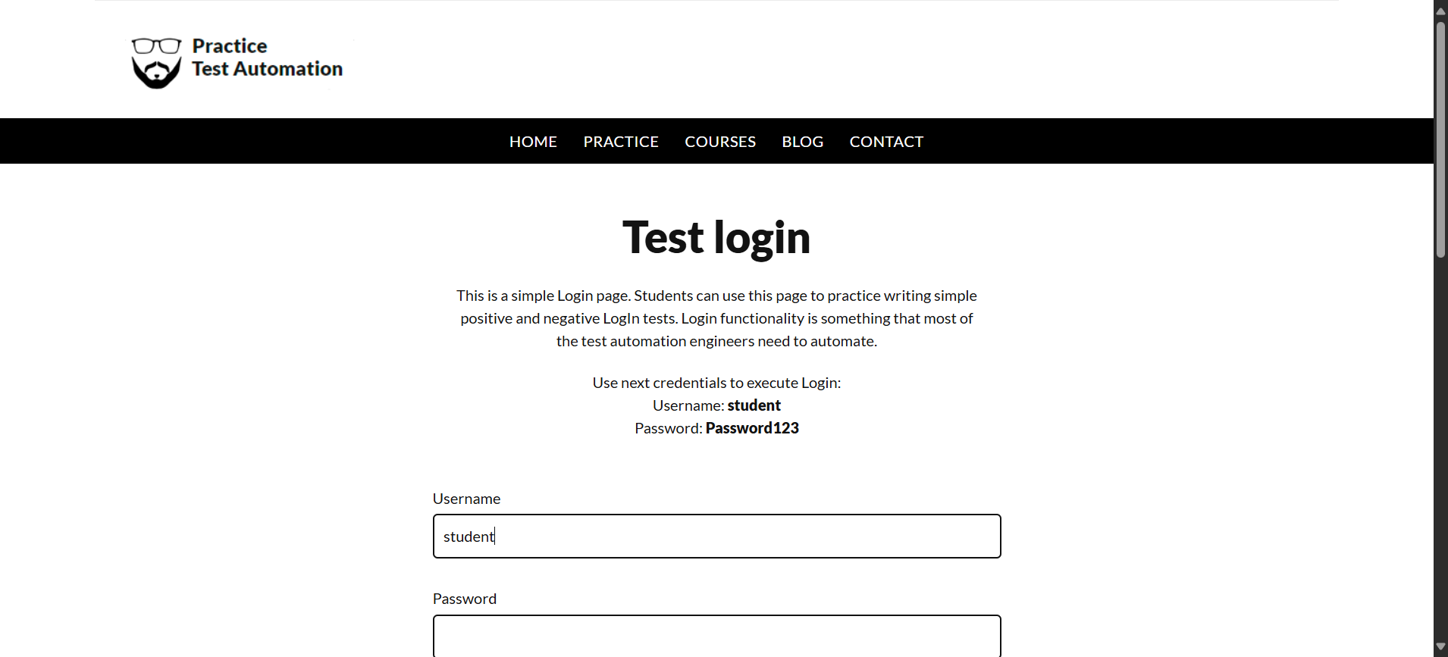

**Step: Enter Password "password" into "Password" textbox at "LoginPage" page - PASS**

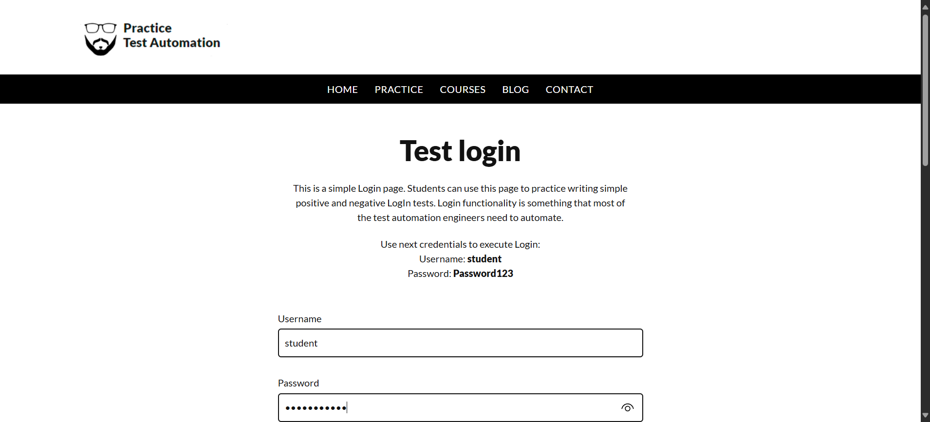

**Step: Click "login_button" element at "LoginPage" page - PASS**

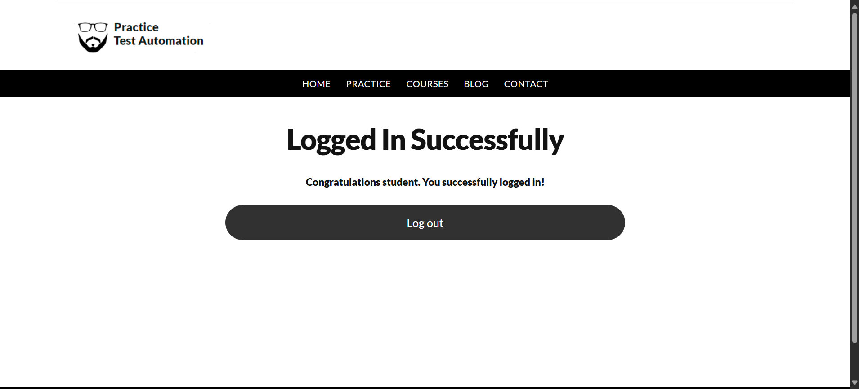

**Execution Summary:  
Total Steps: 4  
Passed: 4  
Failed: 0**

**Scenario: Launch Automation_Practice_Url123**

**Step: Launch "Automation_Practice_Url" WebPage - PASS**



**Step: Enter UserName "username" into "Username" textbox at "LoginPage" page - PASS**



**Step: Enter Password "password" into "Password" textbox at "LoginPage" page - PASS**

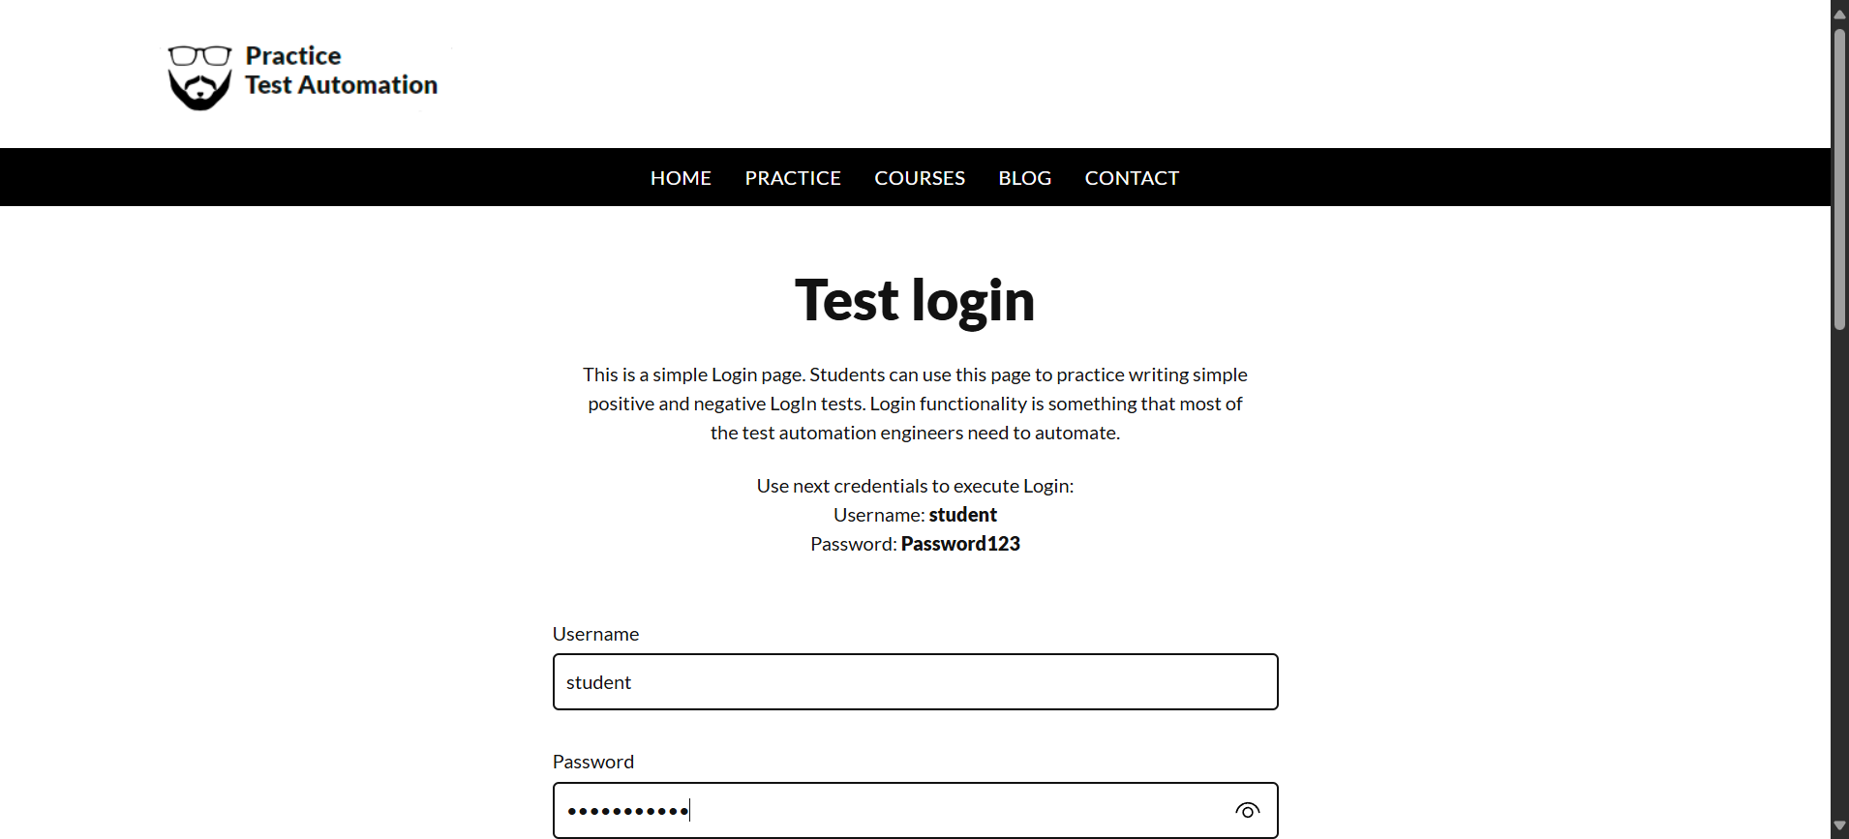

**Step: Click "login_button" element at "LoginPage" page - PASS**



**Execution Summary:  
Total Steps: 8  
Passed: 8  
Failed: 0**